Sensitivity Testing

# Abstract:

The objective of this paper is to highlight how the sensitivity test for macro-economic variables is done for CCAR Models. Sensitivity testing is performed on the final model specification in order to assess the model’s appropriateness for use in the CCAR submission. Sensitivity test is performed on default units and default exposure, GCL, and NCL forecasts.

# What is Sensitivity?

Sensitivity testing is performed on the final model specification in order to assess the model’s appropriateness for use in the CCAR submission. **Sensitivity tests are performed using the base, adverse, and severely adverse scenario.** To measure the sensitivity of the Mortgage model, default units, default exposure, GCL, and NCL are forecasted using the various scenarios.

**Formula 1: Formula to calculate the Sensitivity for Adverse and Severe Adverse Scenario for Default exposure:**

|  |
| --- |
| Sensitivity_Adv= Default Exposure_Adv/Default Exposure_Base  Sensitivity_SevAdv= Default Exposure_SevAdv/Default Exposure_Base |

# Types of Sensitivity Tests:

The sensitivity of the model is evaluated through the following set of tests.

**Table 1: Sensitivity Tests**

|  |  |
| --- | --- |
| Sensitivity Test | Definition |
| ST1 | Base scenario (reflecting production assumption of haircut) |
| ST2 | Adverse scenario (reflecting production assumption of haircut) |
| ST3 | Severely Adverse scenario (reflecting production assumption of haircut) |
| ST4 | Univariate Sensitivity Test: Test the impact of each macro variable and non-model assumptions one at a time by applying the Severely Adverse scenario of one variable and using baseline scenario for other variables |
| ST5 | Sensitivity of Haircut Distribution (Base scenario) |

# How Sensitivity Test is performed (ST1-ST3)?

Sensitivity test is performed on the PD components (default units and exposure), GCL, and NCL forecasts. **In the below, 13 quarter forecasts of 180+ units, balance, GCL, and NCL under baseline and stress (adverse and severely adverse) macroeconomic scenarios are compared.**  The forecast results based on the full sample estimates (ST1-ST3) are discussed below.

**Table 2: Sensitivity for Adverse and Severe Adverse**

|  |  |  |  |  |  |
| --- | --- | --- | --- | --- | --- |
| Population | Base | Adverse | Severely Adverse | Sensitivity: Adverse | Sensitivity:  Severely Adverse |
| Default Units ('000) | 7.00 | 13.00 | 15.00 | 1.86 | 2.14 |
| Default Exposure ($M) | 120.00 | 200.00 | 250.00 | 1.67 | 2.08 |
| GCL ($M) | 5.00 | 25.00 | 50.00 | 5.00 | 10.00 |
| NCL ($M) | 3.00 | 20.00 | 40.00 | 6.67 | 13.33 |

**Explanation of the results:** The model shows sufficient loss separation between base and severely adverse scenarios over the 13-quarter forecast period. **As observed from the result of the sensitivity tests above, the model is very sensitive to macro-economic changes. The model forecasts approximately 2 times higher default units and balance for the cumulative 13Q adverse scenario compared to the baseline scenario.**  For GCL and NCL, the model forecasts approximately 5 times and 6 times higher charge offs under the adverse scenario as compared to baseline forecast, respectively. The model forecasts higher units, balances, GCL, and NCLs under the severely adverse scenario compared to the base scenario with 2 times higher unit forecast and 3 times higher balance forecast.

**Graphical representation of the results (defaults units):** The following charts display the marginal and cumulative forecast scenario curves for default units. The charts provide a visual representation of the model’s separation across scenarios over the forecast horizon. **The rank ordering of the forecasts are as expected over the 13-quarter period, i.e., severely adverse results are more severe than adverse and baseline results.**

**Table 3: Sensitivity for Adverse and Severe Adverse**

|  |  |  |  |  |  |  |
| --- | --- | --- | --- | --- | --- | --- |
|  | Base | Adverse | Severely Adverse | Cumm. Base | Cumm. Adverse | Cumm. Severely Adverse |
| Q1 | 0.5 | 0.5 | 0.5 | 0.5 | 0.5 | 0.5 |
| Q2 | 0.5 | 0.8 | 0.9 | 1.0 | 1.3 | 1.4 |
| Q3 | 0.5 | 1.0 | 1.1 | 1.5 | 2.3 | 2.5 |
| Q4 | 0.5 | 1.0 | 1.1 | 2.0 | 3.3 | 3.6 |
| Q5 | 0.6 | 1.2 | 1.3 | 2.6 | 4.5 | 4.9 |
| Q6 | 0.6 | 1.2 | 1.5 | 3.2 | 5.7 | 6.4 |
| Q7 | 0.7 | 1.4 | 1.6 | 3.9 | 7.1 | 8 |
| Q8 | 0.6 | 1.2 | 1.5 | 4.5 | 8.3 | 9.5 |
| Q9 | 0.5 | 1.2 | 1.4 | 5.0 | 9.5 | 10.9 |
| Q10 | 0.5 | 1.0 | 1.3 | 5.5 | 10.5 | 12.2 |
| Q11 | 0.5 | 1.0 | 1.1 | 6.0 | 11.5 | 13.3 |
| Q12 | 0.5 | 0.8 | 0.9 | 6.5 | 12.3 | 14.2 |
| Q13 | 0.5 | 0.7 | 0.8 | 7.0 | 13.0 | 15.0 |
| Total | **7.0** | **13.0** | **15.0** |  |  |  |

**Figure 1: Marginal forecast scenario curves for default units**

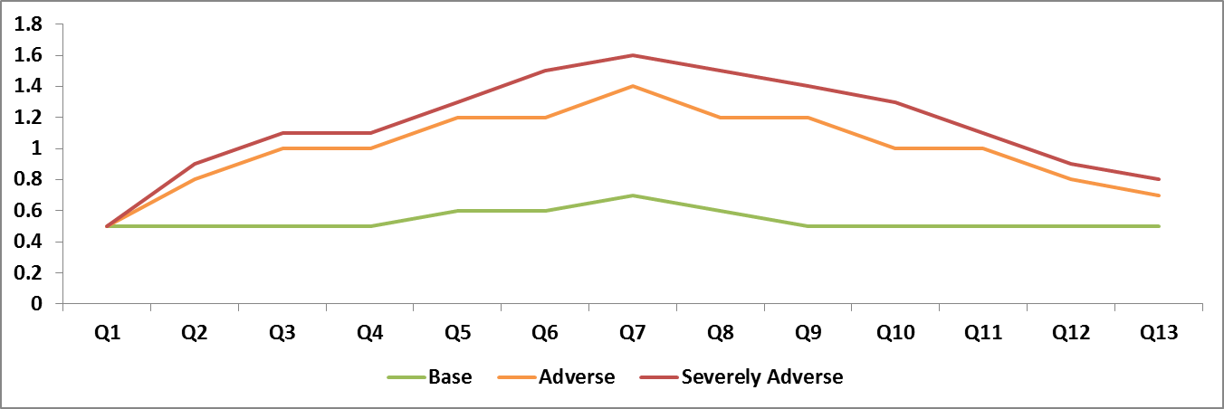

**Figure 2: Cumulative forecast scenario curves for default units**

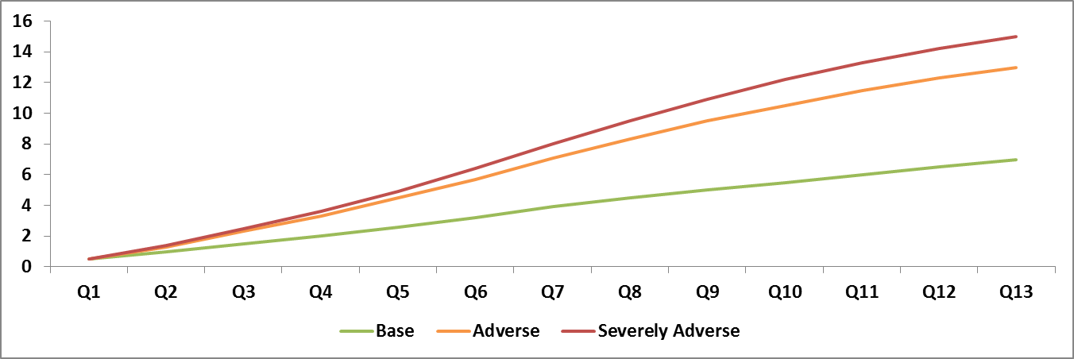

The same trends were observed for default balances, GCL, and NCLs.

# Modelers Comments:

During the model development phase the loan level information and historical macro-economic data is used. **Once the model is finalized then the macro-economic data for various scenarios are imputed in the model to get the corresponding data.**

**Example:** In the model, the 3 macro-economic variables (HPI, Mortgage Rate, Unemployment and GDP) were found significant. The formulas for various scenarios are listed below:

**Formula 2: Formula to calculate the PD for Base, Adverse and Severe Adverse:**

|  |
| --- |
| PD (Model) = Function (HPIhist, MRhist, Unemphist, GDPhist)  PD (BASE) = Function (HPIbase, MRbase, Unempbase, GDPbase)  PD (Adverse) = Function (HPIadv, MRadv, Unempadv, GDPadv)  PD (Sev Adverse) = Function (HPIsadv, MRsadv, Unempsadv, GDPsadv) |

**Table 4: Steps in Sensitivity Testing**

|  |  |
| --- | --- |
| Steps | Model Development Steps |
| Step 1  (Model Development) | The account level PD transition model is created using historical loan level and macro econ data. In general last 7-10 years data is considered for building the model.  **The Model Development Team constructed the Residential Loan Model by leveraging a probabilistic loan state transition matrix model approach combined with an accounting based loss-given-default (LGD) framework and empirically derived recovery assumptions.** Throughout the lifetime of each loan, the model computes the expected outstanding balance as a function of expected amortization or periodic installments, risk adjusted for potential prepayment and default incidence termination risks.  The overall modeling approach follows an account level expected loss framework highlighted in the equation below: **EL = PD*EAD*LGD** |
| Step 2  (Sensitivity Test) | Sensitivity testing is performed on the final model specification in order to assess the model’s appropriateness for use in the CCAR submission. Sensitivity tests are performed using the base, adverse, and severely adverse scenario.  PD = f(Loan level data, macro econ data)   * **Loan level data:** Origination FICO, Loan Type, Property Type, Document Type, etc * **Macro econ data:** HPI, GDP, Unemployment, Interest rate, etc. Further macro econ variables are transformed using different combinations of lags, differences, or percentage change. * **Combination data:** Current Loan to Value (CLTV) |
| Step 3 (Implementation) | The final models are implemented on SAS platform and bi-annual sensitivity runs are done and reported to the FED. |

**Macro-economic data:** During model development the historical macro econ data is used. Macro-economic variables were tested for inclusion in multifactor analysis by comparing correlations to historical transition rates. The pre-defined set of macroeconomic variables, transformations, and lags, was as follows:

* Variables: Home price index (HPI), Real Gross Domestic Product (rGDP), Mortgage rate (MR) , Unemployment rate (UE), 10-Year Government Bond Yield and Consumer price index (CPI)
* Transformations: None, Difference year-over-year (Dyoy), Difference quarter-over-quarter (Dqoq), Percentage difference year-over-year (Pctyoy), Percentage difference quarter-over-quarter (Pctqoq) and 3-month moving average (D3MONMAVG)
* Lags: No lag, 3-mo lag, 6-mo lag, 9-mo lag and 12-mo lag

During the sensitivity test the base, adverse, and severely adverse scenario macro-economic values are used and corresponding default units, default balances, GCLs and NCLs are reported.

# Univariate Analysis (ST4):

**To evaluate the responsiveness of the model to different economic scenarios, each macroeconomic series, were shocked (shifted from the base scenario to the severely adverse scenario) in the forecast period independently.** The results were evaluated and compared to the original base forecasts for the Mortgage model from a quarterly and cumulative perspective. The analysis demonstrates the individual impact of each variable on the severely adverse scenario output, holding all other model factors constant.

**Figure 3: Unemployment Rate – Base vs Severely Adverse**

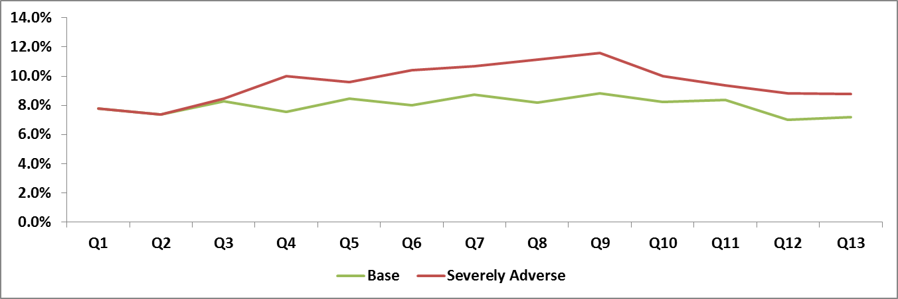

**Example:** The final Mortgage Model specifications include four macroeconomic variables - HPI, Real GDP, Unemployment Rate, and Mortgage Rate. In addition, collateral haircut applied in the model varies by base and stress economic environments. **The chart shows the contribution to NCL by individual variables.**

**Figure 4: The following chart highlights the cumulative impact of each individual factor**

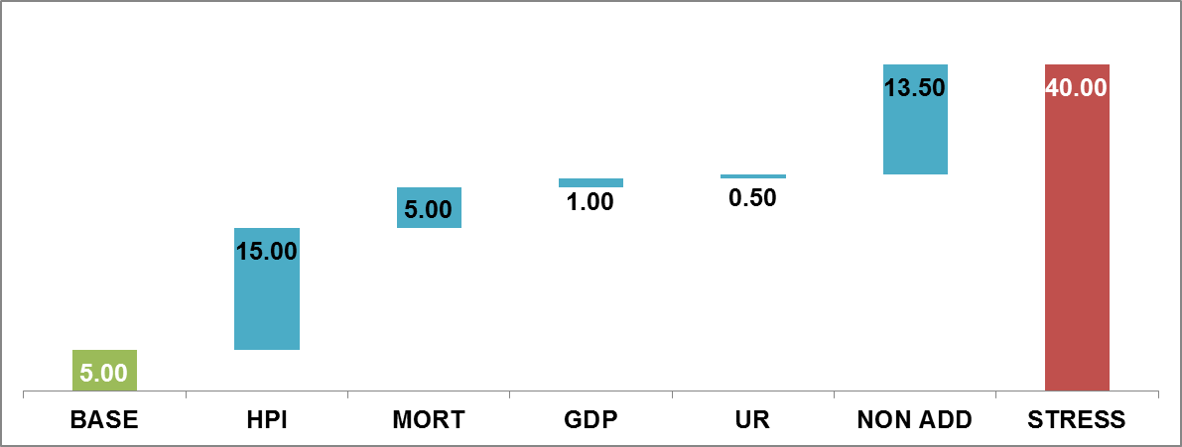

The chart above breaks out the walk from base to stress and shows that all variables contribute to the model sensitivity. HPI contributes approximately 37.5% of the total impact (15 MM out of 40 MM total NCL) whereas Mortgage Rate contributes approximately 12.5% of the total impact.

**Conclusion:** The model is most sensitive to HPI followed by Mortgage rate.

# Collateral Haircut (ST5):

The impact of the collateral haircut on the performance metrics (GCL) is evaluated by fixing the haircut base assumption in increments of 0.05 (11 groups) and comparing the gross credit losses for each haircut assumption used. The results are shown in the figure below.

**Figure 5: Sensitivity of GCL to Changes in the Collateral Haircut Assumption**

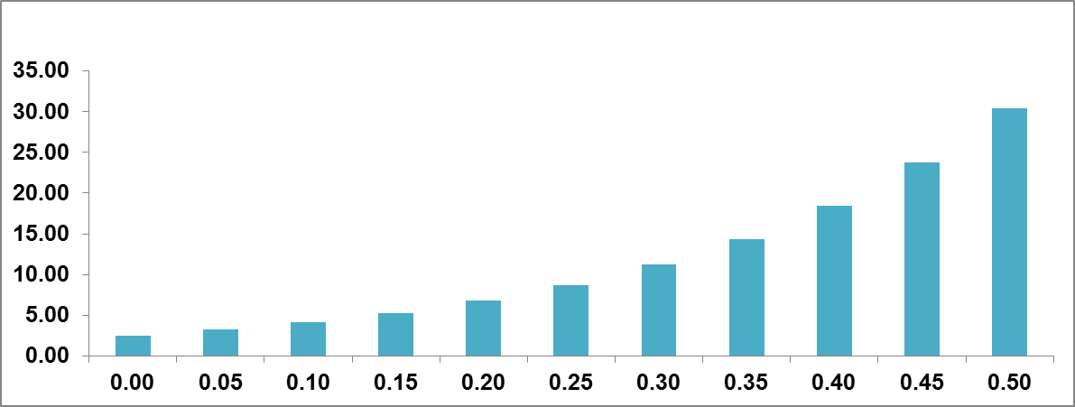

**As shown in the figure, the higher the collateral haircut base value applied in the model, the larger the gross credit losses for the Mortgage portfolio.** This is consistent with expectations as higher haircuts imply lower distressed collateral values, and consequently larger gross credit losses.